**SETTING PATH IN PYTHON**

Before starting working with Python, a specific path is to set.

* Your Python program and executable code can reside in any directory of your system, therefore Operating System provides a specific search path that index the directories Operating System should search for executable code.
* The Path is set in the Environment Variable of My Computer properties:
* To set path follow the steps:

Right click on My Computer ->Properties ->Advanced System setting ->Environment Variable ->New

In Variable name write path and in Variable value copy path up to C://Python(i.e., path where Python is installed). Click Ok ->Ok.

Path will be set for executing Python programs.

1. Right click on My Computer and click on properties.

2. Click on Advanced System settings

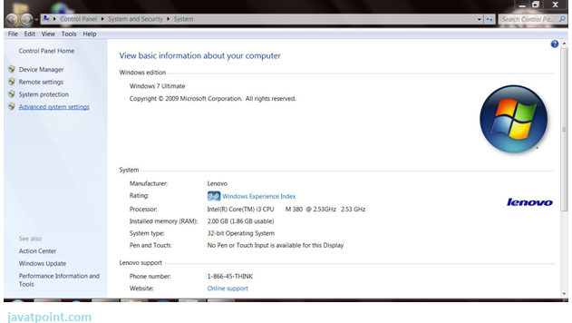

3. Click on Environment Variable tab.

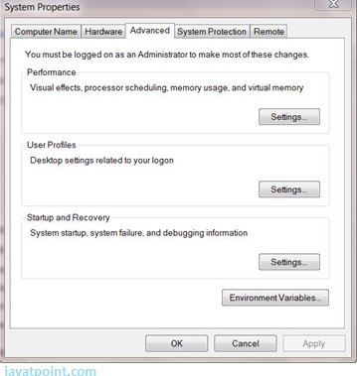

4. Click on new tab of user variables.

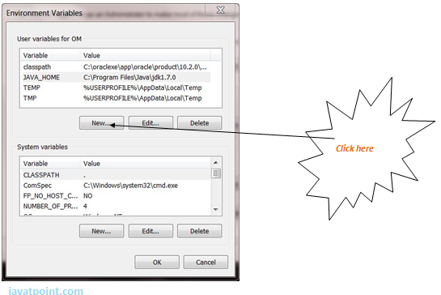

5. Write path in variable name

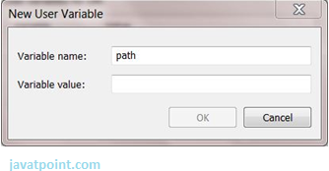

6. Copy the path of Python folder

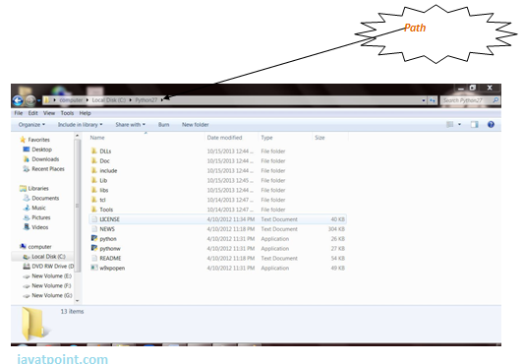

7. Paste path of Python in variable value.

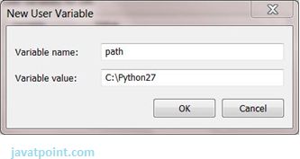

8. Click on Ok button:

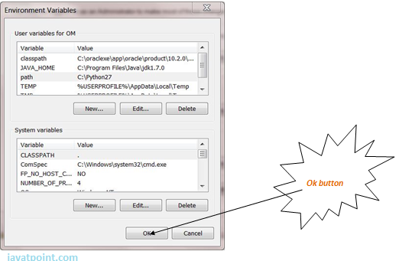

9. Click on Ok button:

